Practical No. 10
Aim : ALP to arrange numbers in Array in Descending array
Name : Danish Altaf Solkar Class : CO - B
Enrolment no. : 24111590805 Batch : 2
Code :-
assume cs:code
assume ds:data
data segment
arr DB 10H,06H,23H,15H,01H
data ends
code segment
start:
MOV AX,data
MOV DS,AX
MOV AX,0000H
LEA SI,arr
MOV CH,04H
UP:LEA SI,arr
MOV CL,04H
UP1:MOV AL,[SI]
MOV BL,[SI+01]
CMP AL,BL
JNS DOWN
XCHG AL,BL
MOV [SI],AL
MOV [SI+01],BL
DOWN:INC SI
DEC CL
JNZ UP1
DEC CH
JNZ UP
INT 03H
code ends
end start

OUTPUT :-
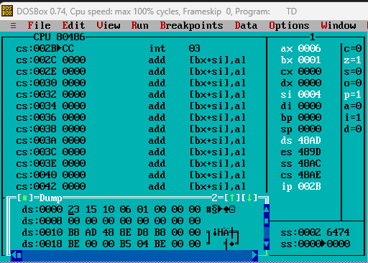

Process related  (15) | Product related  (10) | Total Marks  (25) | Signature

